Development and Validation of a Novel Posture Monitoring System

Sai Sri Harini.C   
*Biomedical Department*  
*PSG College of Technology*Coimbatore, India

Syed Althamish ur Rahman   
*Biomedical Department*  
*PSG College of Technology*Coimbatore, India

Sarvesh Rajavel.R  
*Biomedical Department*  
*PSG College of Technology*Coimbatore, India

Kefira Jane.J  
*Biomedical Department*  
*PSG College of Technology*Coimbatore, India

*Abstract*—In contemporary society, posture-related musculoskeletal disorders are on the rise due to extended periods of sedentary behavior and repetitive tasks with people spending most of their time slouching and hunching over desktop screens, tablets and mobile phones. This continuous behavior over extended periods of time causes severe upper and lower backpain that subsequently leads to cervical spondylosis and bulging of lumbar discs. In response to the prevalence of this issue, we have developed a posture monitoring system realized through a shoulder strap to capture the siting posture of individuals. This is achieved by utilizing 3 IMU sensors to monitor and Machine Learning Algorithms to classify. The classification algorithms were trained with data acquired from 12 healthy individuals and the bests chosen one is the KNN algorithm with an accuracy of 99%. The system was further validated with a real time validation routine and was identified with 80% accuracy.

Keywords—IMU, Spinal Posture, Data Classification

# Introduction (*Heading 1*)

Sitting is one of the most common postures in daily life [1.2-7], with studies indicating that people spend around six hours sitting each day. Consequently, back pain has become a widespread and troubling issue, now ranking as the third most common reason for individuals to seek medical attention [3.?]. Approximately 70-80% of those experiencing back pain attribute it to poor posture [d1?]. Chronic back pain develops gradually due to sedentary behavior, often exacerbated by prolonged use of digital devices. This has resulted in 15-19% of people suffering from upper back pain and 60-70% from lower back pain [d1?].

The most frequent activity while sitting is using mobile phones, with an estimated 4.77 billion users worldwide as of 2017. This number was projected to increase to 5.07 billion by 2019 [2.1]. As more essential services are integrated into smartphones, and with the growing number of mobile applications, this has further promoted a sedentary lifestyle. Alarmingly, a recent study reveals that looking down at a phone is comparable to placing 60 pounds of pressure on the neck [4.1]. Correspondingly, another study highlighted that a condition known as "Text Neck," caused by 60 pounds of neck pressure, can lead to Kyphosis [2...?]This disease is an excessive spine curve because of abnormal rounding of upper back. which can lead to breathing problems that may eventually require a surgical treatment.[4.?].

Chronic Low Back Pain (CLBP) is another significant cause of disability, affecting similar populations across various countries and cultures, with one in five adults experiencing CLBP each year [1.2]. In industrialized nations, chronic pain is rapidly becoming the foremost health issue, contributing to annual low back pain costs of $100-$200 billion [1.4].

Acute back pain, which often results from injuries like muscle strains or ligament tears due to activities such as heavy lifting or sudden movements, can also lead to considerable discomfort and mobility limitations [d.?]. Back pain significantly affects an individual’s quality of life, reducing productivity, limiting movement, and causing emotional distress. Studies have found that slouched or hunched posture not only reduces energy levels but also negatively impacts mental well-being, such as happiness and depression [2.4]. Poor posture also affects workplace productivity, with approximately 75% to 85% of worker absenteeism being attributed to recurrent or chronic back pain [1.6].

Despite its prevalence, simple preventive measures can effectively mitigate these disorders. According to medical research, most cases of severe Kyphosis can be treated and prevented through exercises aimed at improving posture and maintaining a straight spine [4.2]. A study by Robertson et al. [5.1] found that musculoskeletal risk decreased after 16 months of ergonomic posture training for seated individuals. Further studies by Choobineh et al. [5.2] and Menendez et al. [5.3] demonstrated that ergonomic interventions could reduce musculoskeletal discomfort and related symptoms. Additionally, research by Taieb-Maimon et al. [5.5] showed that posture risk diminished after three weeks of an experiment using a camera to display the seated individual’s sagittal posture. Therefore, maintaining proper spinal posture is possible and essential, which is the goal of our system’s design.

Several systems have been developed to address this issue, comprising three main components: data collection, data analysis, and feedback [4.?]. Our system incorporates all these elements, with a particular focus on analyzing the collected data while in a seated position.

# System Architecture

Our system's operation primarily depends on the data acquired by IMU sensors placed on the body, which are then pre-processed to extract features. These features are then fed to a classifier to identify the user's sitting posture, therefore notifying the user.

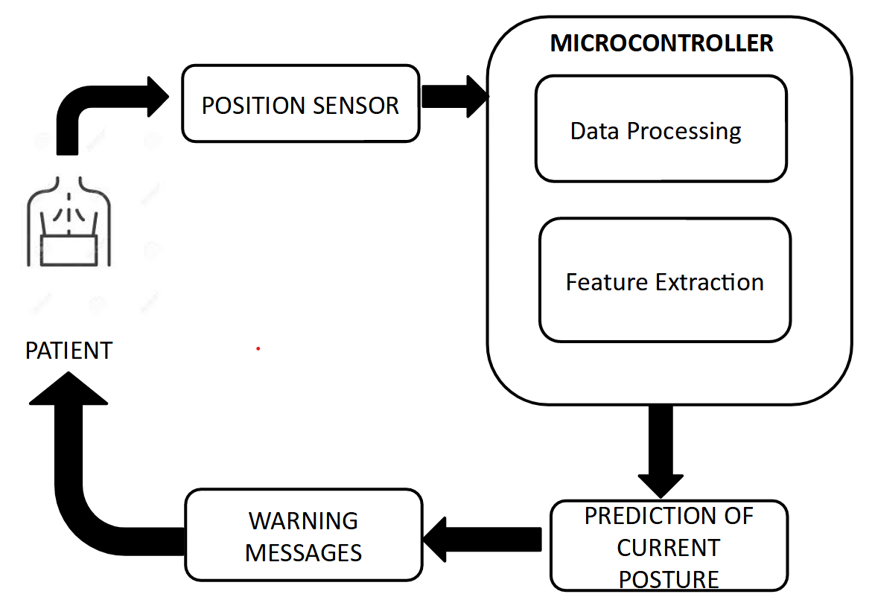

## Design:

Our system is designed to extract movement/ orientation related data in sitting posture from 3 different locations. These locations are:

* The Acromion Process
* The T5 vertebrae
* The Sternum {SAII}

The Acromion process and t5 vertebrae has been chosen since it provided remarkable accuracy in existing posture monitoring systems that use IMU sensors[ref]. This is understandable due to the significant deviation in its location and orientation during postural changes. The thoracic junction is used as location to counter the system's bias towards the posterior of the body with the T5 vertebrae. This location proved to be the best location to extract data from the anterior of the body.

The placement of these sensors were achieved using a Neoprene Velcro shoulder strap described in fig 1. This adjustable shoulder strap's surface are covered all the 3 mentioned areas and was as a result used to embed the sensors within. Care was taken to not let the shoulder strap's influence affect the user's normal posture. The acromion and t5 sensors were fixed whereas the chest sensor was adjustable to relocate the sensor to correct position for different individuals with different widths. The sensors used for this purpose is MPU-6050 which is capable of acquiring 6 dof , viz, acceleration and rotational speed in all 3 axes. These data were capable of transmitting through I2c medium for fast multi-device communication aiding our purpose. Also is low power.

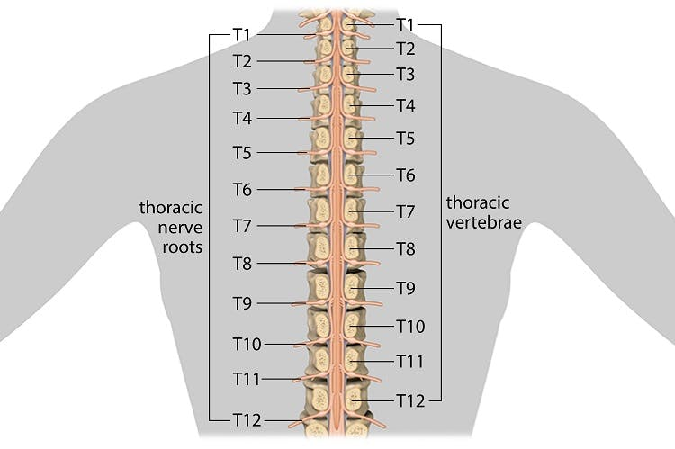The processing unit was to be located within the vicinity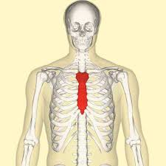 of the sensors therefore it was embedded within the strap near the acromion process since it held enough space to hold the mpu. The processing unit was connected to the sensors using a series of wires designed to align with the strap's structure. There are some limitations to its placement, with reports of discomfort arising from its inflexible structure. The objective of our system is to improve the processing and classification, therefore the processing unit's size had been reduced as much as possible, but ideally needs to be flat and flexible with zero protruding height. The processing unit chosen is RP Pico for its small size and greater memory in 20kb sram. It also has in built libraries for future prospectes of embedded ML algorithms. Also is low power.

A BLE module was also used to transfer the relevant data to the Classifier present in the PC. A HC-05 was used explicitly for its accessibility to high speeds and low power operation.

The Classifier was present in the PC of the user, running in the background. It classified based on the data from the BLE module and presented relevant info to the user when needed. The classifier chosen for this purpose was KNN. This classifier was selected for after its better performance from a set of experiments run detailed in the following sections. The classifier took a mean time of 1.5s for inference.{saii}

## Operation

Once the shoulder strap embedded with the sensors and the processing unit is worn by the user, the user is expected to perform a calibration routine. This calibration routine is done to eliminate the Zero-Error that arises from the gyroscopic measurements from each user. During this 10-sec routine, the user is expected to sit in a static neutral posture depicted in fig.1. The zero-error bias is calculated by averaging the static gyroscopic signal.

Eac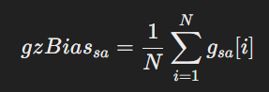h sensors output a 6 dof measurement viz, acceleration and rotational speed in all 3 axes. Each sensor is sampled at 45Hz given the processing limits of the Pico. While the acceleration signal is not pre-processed, the gyroscopic signals are altered by subtracting from it the zero-error bias value calculated from the calibration routine. This error allows gyroscope to output true zero values. The processing unit then acquires these signals and processes to extract new information known as tilt. The tilt is calculated in two ways: one using complementary filter and the other using only acceleration signals.

The complementary filter considers both acceleration and gyroscopic observations to calculate the tilt given the formula depicted below.The complementary filter effectively combines the low-frequency stability of the accelerometer (which measures tilt based on gravity but is susceptible to noise from linear movements) with the high-frequency responsiveness of the gyroscope (which tracks rotation but drifts over time). This fusion helps to maintain a more reliable and stable estimate of tilt angles, reducing noise and drift. It applies a weighted combination of the accelerometer and gyroscope data. The optimal weight chosen for this is 0.95. The formula is further advanced to wrap around +180 to -180 degrees the signal to better compensate the drift accumulated by gyroscopic readings. Despite complementary filter's advantage over the acceleration based tilt, due to the static nature of sitting postures, both of their significance is taken into account



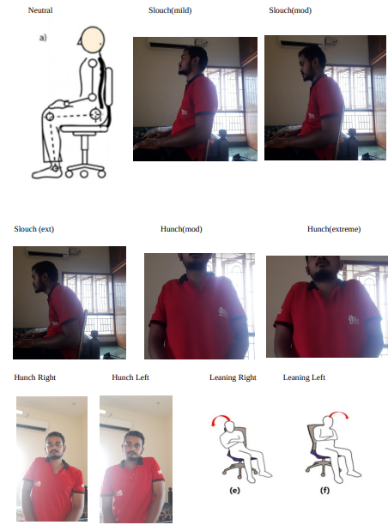

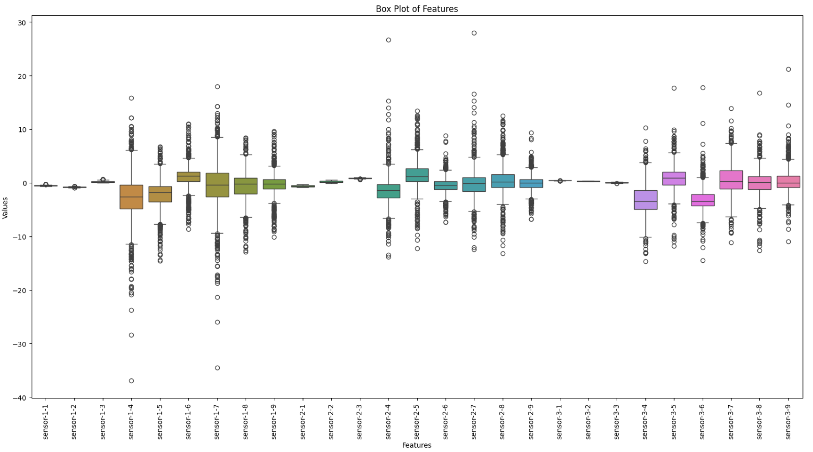From all the features extracted the meaningful ones are sent to the classifier via the BLE module using a UART module to communicate with the processor. The classifier is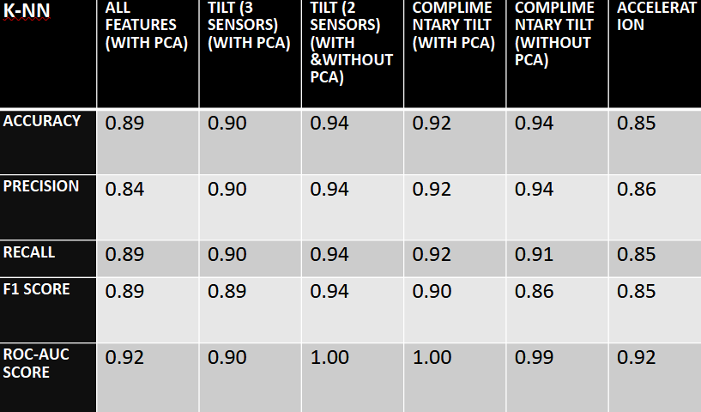 then used to identify the correct posture of the user. This posture is displayed to the user via an application.{saii}

# Feature Selection and Training{saii}

For the purpose of analyzing the data and training the ML algorithms with respect to it, appropriate data needs to be acquired. The following section highlights how that data was acquired.

## Data set Acquisition:{saii}

The data was acquired from 12 healthy individuals with a mean age, height and weight of x, y, z. Their respective data is given below in the table 1.

The data acquisition routine began with the user being requested to undergo the calibration routine outlined in the above section. The user was then asked to relax and begin with the first posture being neutral. Each user was seated in a stool with no back support. The user was requested to stay in a specific posture for 10-15 seconds each. The user was asked to best represent the postures depicted in fig.4. The order of each posture being taken is:

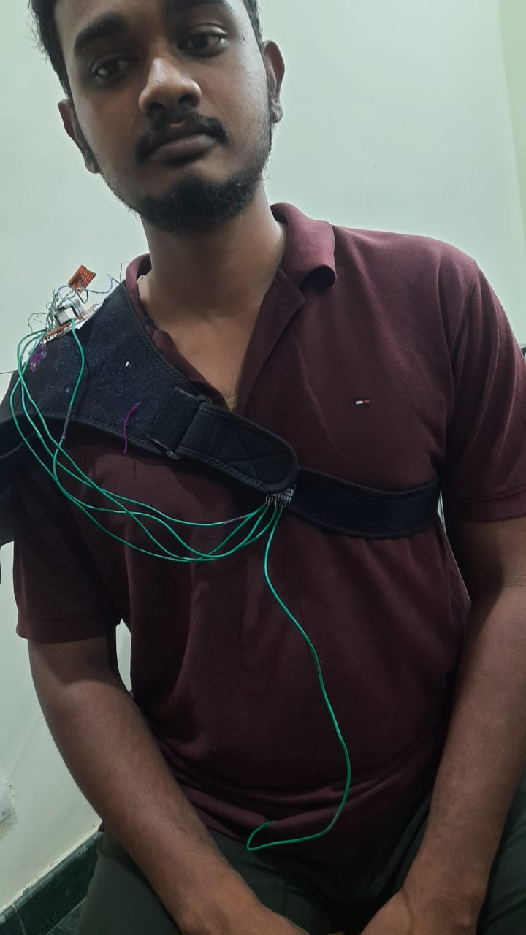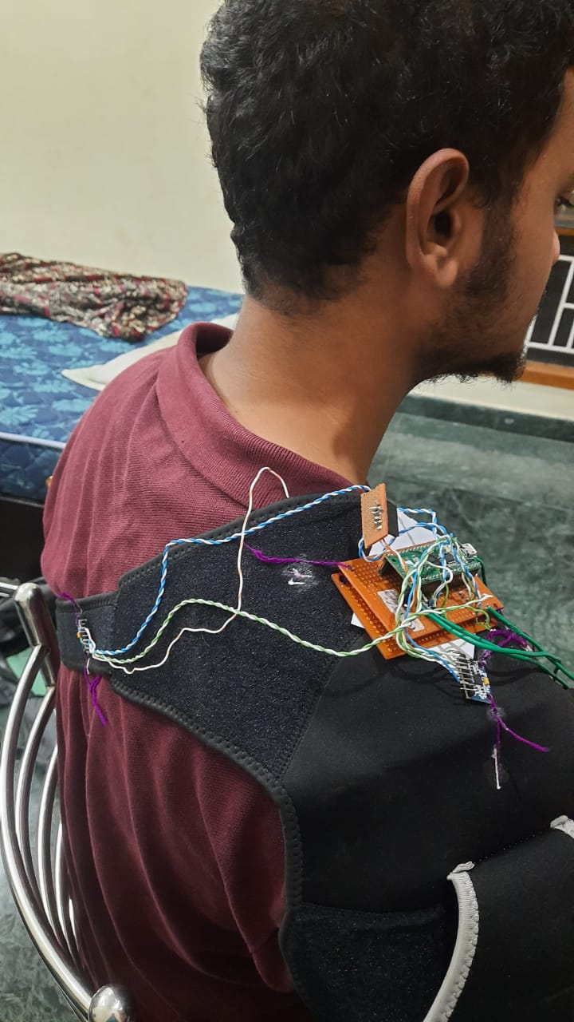

* Neutral
* Slouch Mild
* Slouch mod
* Slouch ext
* Hunch Mild
* Hunch ext
* Hunch right
* Hunch left
* Lean right
* L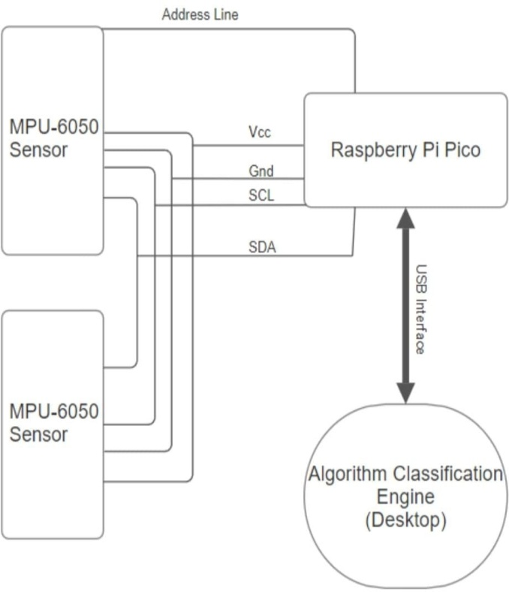ean left

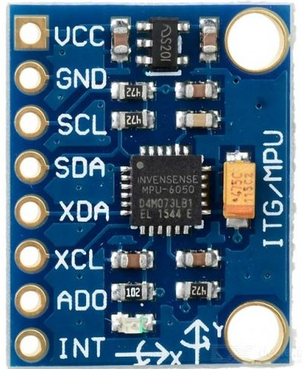As such 94000 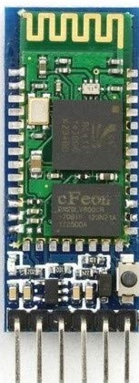data points were 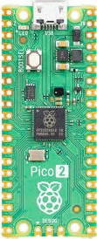observed with approx. 9000 datapoints per posture.

## Feature Set Selection:{saii}

Including the raw data measurements from each sensor, and subsequently derived tilt angles using two different methods there is a total of 33 features. Each sensor has 11 features with 6 dof raw data measurements a 5 tilt angles with x and y being derived from both complementary filter and acceleration data and z only being derived from acceleration. Among the 33 features there were some features that were deemed redundant given by the details of said features outlined in table 5. The ideal posture monitoring system would be a stand-alone system worn by the user not requiring any external processing mechanism. Therefore in order to aid this objective, a feature reduction/selection process was undergone to determine the best features. The methods used for feature selection and extraction and their reasons are given below:

-

-

-

## Classifier Selection:{saii}

Multiple ML models were experimented with to find out the best performing model. This model was deemed KNN providing 94% accuracy with only 2 or 3 of user-selected features. viz, x and y axes complementary tilt angles. The performance details of each classifier is detailed in table 9. The testing and training set were divided by a 0.75 ratio.

# Result{saii}

Our system's design is aimed around the objective of efficient and accurate monitoring of the sitting posture. As a result, its final design comprises of 3 sensors whose raw data in used to extract a derived feature known as tilt. The best performing variation of tilt derivation is deemed from the complementary filter's derivation. The best classifier to identify the posture is found out to be KNN classifier which provided an accuracy of 94%. Though the classifier has been trained from a limited dataset of only 12 people, the system would benefit from more data to be trained with. It has also been found out that an additional third sensor in the posterior of the body seems to reduce the accuracy of the classifier, therefore labelling it unnecessary.

# Conclusion:{Saii}

The task of posture monitoring with IMU sensors is a difficult but possible task with our system providing 94% accuracy. This system can be used to primarily monitor sitting posture ideally during seated work. The use of IMU sensor allow for maximum privacy to the user's actions while maintaining a decent level of accuracy. Due to its low power nature it can be used anywhere and can be thus used to acquire postural data over large periods of time with very little effort from the user's side. However its design could benefit from improvements with the reduction of the processing unit's size and increase its flexibility by the addition of flexible electronics. The system's could increase its performance with the general population by having access to a large variety of patients data, involving patients from a wide variety of ages, weights and heights. Furthermore, the calibration routine undergone by the user at the start of every monitoring period can also be replaced by efficient, less time-consuming methods that do not impose restrictions on the user. The convenient setup of a shoulder strap can be replaced with textile-embedded electronics to further enhance the user's comfort. The system could further incorporate the ML algorithm within its processing unit allowing it to operate as a stand-alone system.

##### References

1. G. Eason, B. Noble, and I. N. Sneddon, “On certain integrals of Lipschitz-Hankel type involving products of Bessel functions,” Phil. Trans. Roy. Soc. London, vol. A247, pp. 529–551, April 1955. *(references)*
2. J. Clerk Maxwell, A Treatise on Electricity and Magnetism, 3rd ed., vol. 2. Oxford: Clarendon, 1892, pp.68–73.
3. I. S. Jacobs and C. P. Bean, “Fine particles, thin films and exchange anisotropy,” in Magnetism, vol. III, G. T. Rado and H. Suhl, Eds. New York: Academic, 1963, pp. 271–350.
4. K. Elissa, “Title of paper if known,” unpublished.
5. R. Nicole, “Title of paper with only first word capitalized,” J. Name Stand. Abbrev., in press.
6. Y. Yorozu, M. Hirano, K. Oka, and Y. Tagawa, “Electron spectroscopy studies on magneto-optical media and plastic substrate interface,” IEEE Transl. J. Magn. Japan, vol. 2, pp. 740–741, August 1987 [Digests 9th Annual Conf. Magnetics Japan, p. 301, 1982].
7. M. Young, The Technical Writer’s Handbook. Mill Valley, CA: University Science, 1989.
8. K. Eves and J. Valasek, “Adaptive control for singularly perturbed systems examples,” Code Ocean, Aug. 2023. [Online]. Available: <https://codeocean.com/capsule/4989235/tree>
9. D. P. Kingma and M. Welling, “Auto-encoding variational Bayes,” 2013, arXiv:1312.6114. [Online]. Available: <https://arxiv.org/abs/1312.6114>
10. S. Liu, “Wi-Fi Energy Detection Testbed (12MTC),” 2023, gitHub repository. [Online]. Available: https://github.com/liustone99/Wi-Fi-Energy-Detection-Testbed-12MTC
11. “Treatment episode data set: discharges (TEDS-D): concatenated, 2006 to 2009.” U.S. Department of Health and Human Services, Substance Abuse and Mental Health Services Administration, Office of Applied Studies, August, 2013, DOI:10.3886/ICPSR30122.v2